**Phase 4 - Course-end Project 1**

**Online Test Application**

**Developed by:** Narendra Kumar .V

(Emp-ID_10847)

**DESCRIPTION**

The Online Test Application system creates an application that enables users to provide online tests, review them, and display the results.

**System Details**  
This system contains three main modules: Quiz, Review, and Result. The quiz section of the online test application accepts the questions in JSON format. The JSON file can be easily shared from the server in the pre-defined format. The application renders the test at the client-side.

The “Review and display result” section allows users to declare the results immediately. You can simply call another JSON with the answers in it and evaluate and display the results immediately.

**Project OverView:**

In this project there are 3 modules Quiz , Review and Result,

In the First part there will be questions displayed of selected quiz

After completing the quiz user will be able to view the all answered and unanswered questions after that result will be displayed

In the Landing page we will display different quiz’s like

1.Java Quiz

2.Java Script Quiz

Upon clicking any one of them they will be redirected to quiz page where the corresponding quiz question will be displayed

To implement that I have passed a value in href tag in index page and read that value in javascript in the quiz page

Index.html

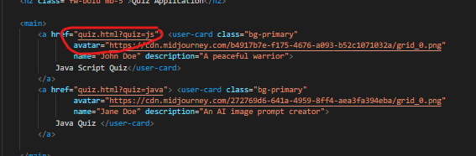

Quiz.html

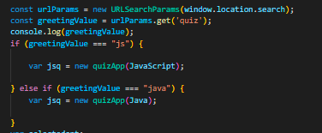

Typically these type of projects are not developed only by using HTML,CSS & JavaScript But I wanted to try Using Advance JavaScript.

**Sprint Planning:**

|  |  |  |
| --- | --- | --- |
| **Sno** | **Sprint** | **Duration** |
| **1** | Json format is defined on how the data should be | 1-day |
| **2** | User interface coding is done like forms and buttons | 2-days |
| **3** | Form validation ,quiz Review is done using JavaScript | 4-days |

**Technologies Used:**

Html5

CSS3

JavaScript

Json

**Project Git hub link:** [Github Online Quiz ApplicationProject](https://github.com/Naren487/Teksystems/tree/main/Phase%204/Online%20quiz%20Application)

**Conclusion and Unique Selling Points:**

This is a static website created using advance java Script by sharing the json data of any quiz we can add the quiz directly